**VBA User Forms**

Add a new user form

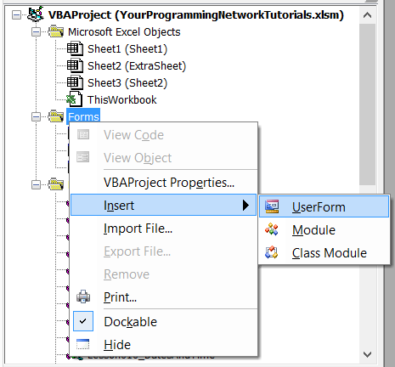

Let's call it **frmSchet**

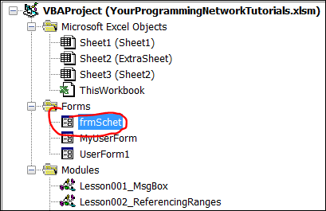

Change the form by adding controls

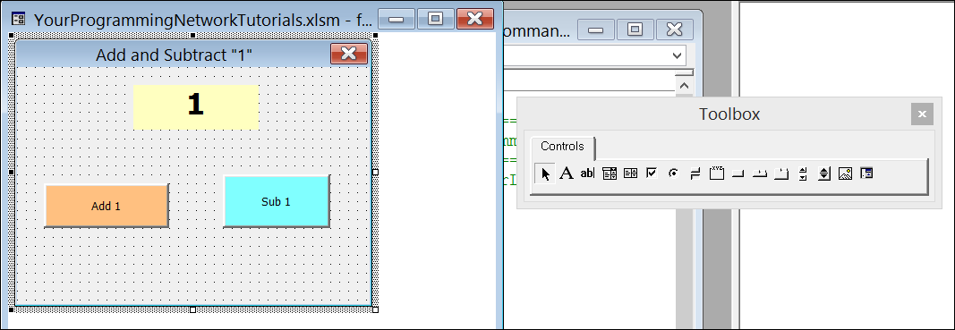

Click on the left button to change the properties

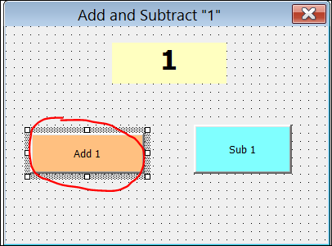

Let's assign another name to it, e.g. btnAdd

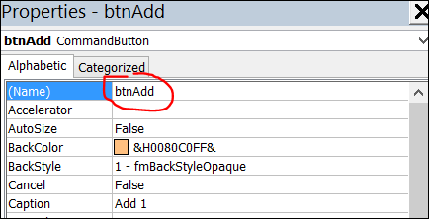

Double click on the left button to assign a task to it

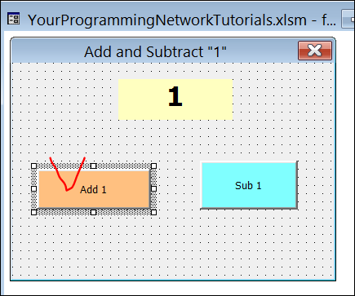

Write your code here

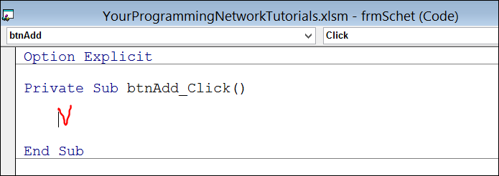

For example, we want the label to add 1 when we click on this button

'==============================================================================

Private Sub btnAdd_Click()

frmSchet.lblMyLabel.Caption = frmSchet.lblMyLabel.Caption + 1

End Sub

'==============================================================================

To program another button we can select another control and event.

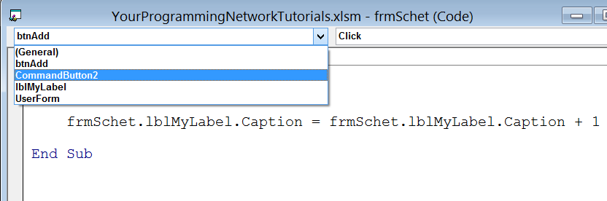

Let's select "CommandButton2" and "Click" action

We'll get an empty sub for this control

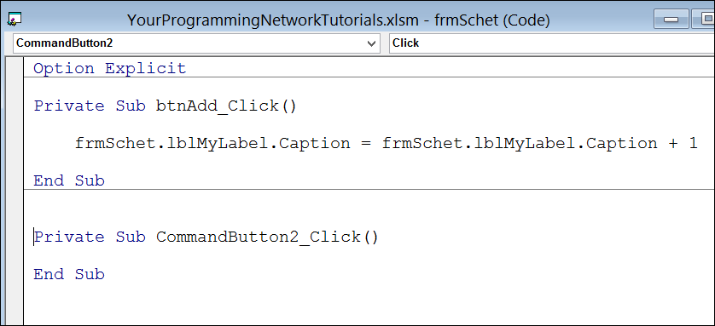

Add the following code:

'==============================================================================

Private Sub CommandButton2_Click()

frmSchet.lblMyLabel.Caption = frmSchet.lblMyLabel.Caption - 1

End Sub

'==============================================================================

To view how the form works

* Open the form
* Click F5

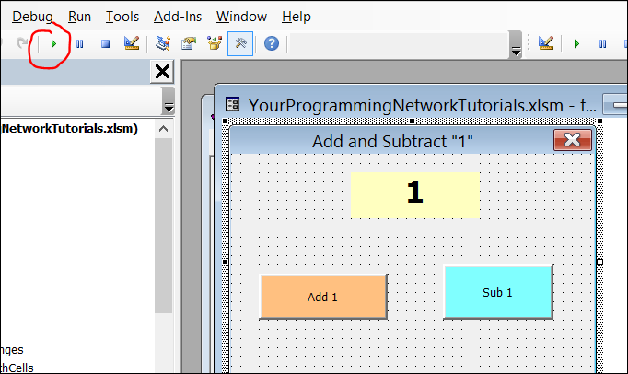

To run the form from the other sub

* Create a new sub
* Add the following code

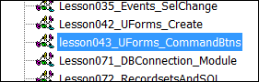

Sub runSchetForm()

**frmSchet.Show()**

End Sub

The code will trigger the form and it appears on the screen.

--================================================

To view the code that belong to the form

* Right click on the form
* Select "View Code"

